Modelling a robot arm

KR 10 R 1100-2

1. ***Kinematic model of a robot***

Robots have 2 types of joints : a) Translational

b) Rotational

Translational moves can be described as

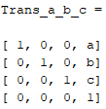

Rotational moves around some axis can be describe as

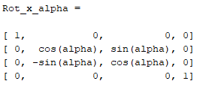

Kinematic analysis of a robot includes two aspects:

1. Forward kinematic (FK)
2. Inverse kinematic (IK)
   1. ***Forward kinematics***

Given: geometry parameters of the links and variables of the joints

Find: the location and pose of end-effector in a given reference frame

The relationship can be derived using Denavit – Hartenberg convention

The joint diagram is shown in Figure 1

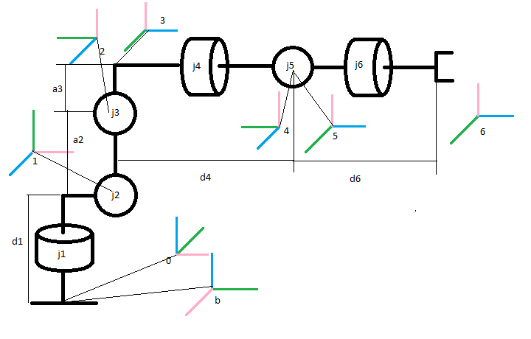

Figure 1. Joint diagram

DH parameters are given in Table 1

|  |  |  |  |  |  |  |
| --- | --- | --- | --- | --- | --- | --- |
| i | Theta | d | a | alpha | Theta_min | Theta_max |
| 1 | q1 | d1 | a1 | 90 | -170 | 170 |
| 2 | q2 | 0 | a2 | 0 | -190 | 45 |
| 3 | q3 – 90 | 0 | a3 | 90 | -120 | 156 |
| 4 | q4 | d4 | 0 | -90 | -185 | 185 |
| 5 | q5 | 0 | 0 | 90 | -120 | 120 |
| 6 | q6 | d6 | 0 | 0 | -350 | 350 |

Table 1. DH parameters

H_06 = H_01 * H_12 * H_23 * H_34 * H_45 * H_56

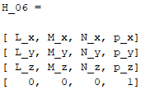

P – position L, M, N – orthogonal vectors

* 1. ***Inverse kinematics***

We try to decouple problem into two simpler problems:

1. Inverse position kinematics
2. Inverse orientation kinematics

Our plan:

1. Find position of the intersection of the wrist axes
2. Find orientation of the wrist

Wrist position can be found as:

w_x = p_x – d_6 * N_x

w_y = p_y – d_6 * N_y

w_z = p_z – d_6 * N_z

We have 2 solution for q1:

q_11 = atan2(w_y, w_x)

q_12 = atan2(w_y, w_x) + pi

and that why we have a group of q2 and q3

q_21 = alpha + beta

q_31 = 1/2 * pi - sigma + gamma

q_22 = alpha - beta

q_32 = -3/2 * pi + sigma + gamma

q_23 = pi - alpha - beta

q_33 = -3/2 * pi + sigma + gamma

q_24 = pi - alpha + beta

q_34 = 1/2 * pi - sigma + gamma

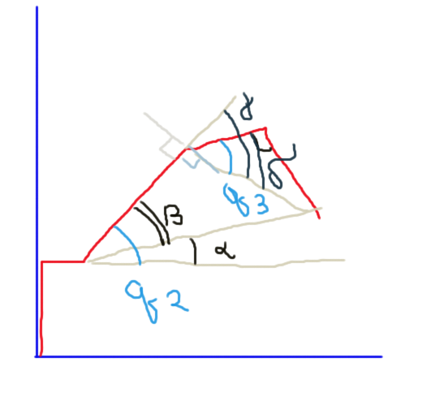

Inverse orientation kinematics

R_03 can be obtain from H_01, H_12, H_23



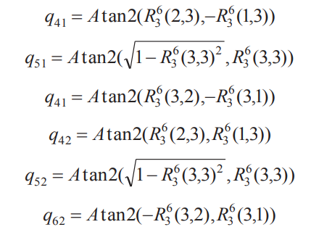

I definitely understand this stuff